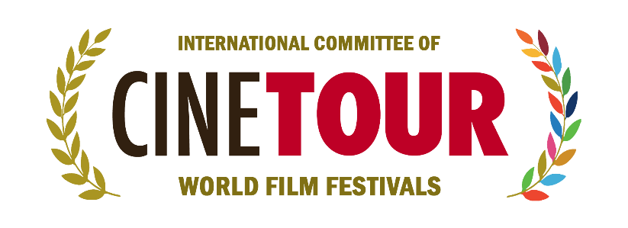

CINETOUR / World Film Festivals Committee
Founded in Istanbul in 2023, the World Film Festivals Committee has reached its third year with nearly 120 film festival members from 68 countries. In this respect, it holds the distinction of being the first and only committee of its kind in the world. With the aim of building cultural bridges among nations, CINETOUR continues to expand its global network by welcoming new member festivals and countries each year. Established to strengthen cooperation and solidarity among film festivals worldwide, CINETOUR’s importance and international influence continue to grow steadily.

CINETOUR’S CULTURAL MISSION…
CINETOUR – the World Film Festivals Committee – is an international platform dedicated to building lasting connections among countries, cultures, and societies through the universal language of cinema. Founded in Istanbul, this initiative has rapidly evolved into a strong global cooperation network, highlighting cinema’s unique potential to promote peace, dialogue, and cultural diversity. CINETOUR pursues its mission in alignment with UNESCO’s vision of cultural heritage, the European Union’s principles of cultural cooperation, and the United Nations’ goals for sustainable peace.

DIFFERENT CULTURES, DIFFERENT FESTIVALS ON THE SAME STAGE…
By bringing together film festivals from diverse regions of the world, CINETOUR embraces cultural diversity as a shared value and a source of strength. Each festival contributes its own story, identity, and perspective to this common platform, creating an inclusive space for universal dialogue through cinema. These encounters foster intercultural understanding and help replace prejudice with empathy and shared values. From Japan to the United States, from South Africa to the United Kingdom, 120 festivals representing different cultures come together under the CINETOUR umbrella. The shared goal of this vibrant global family is to promote cultural cooperation and international solidarity.

THE GROWING ROLE OF FESTIVALS IN COUNTRY PROMOTION…
Film festivals are not only artistic events; they are also powerful instruments of cultural diplomacy. Festivals operating under the CINETOUR network have the capacity to showcase the cultural heritage, contemporary artistic vision, and social values of their cities and countries on a global scale. In this way, festivals have become influential platforms that enhance international visibility while supporting sustainable tourism and cultural exchange. As their impact increases, so does their responsibility. Through its extensive international network, CINETOUR generates strong momentum for the promotion and global engagement of its member festivals.

SUSTAINABLE AND STRONG FESTIVALS TOGETHER…
CINETOUR adopts a forward-looking approach that considers not only the present but also the future of film festivals. Sustainable cultural policies, environmental awareness, inclusive governance, and institutional resilience are among the committee’s core priorities. In line with the United Nations Sustainable Development Goals, CINETOUR develops shared solutions to ensure the long-term sustainability and strength of festivals. By facilitating film exchanges, strong jury participation, and high-quality content creation, CINETOUR serves as a comprehensive platform for collaboration and knowledge sharing. This international cultural cooperation plays a vital role in strengthening festivals and ensuring their continuity.

CINETOUR AT ITS 3RD YEAR: A STRONG GLOBAL FAMILY…
In its third year, CINETOUR has grown into a strong global family bringing together nearly 120 film festivals from 68 countries. This family is built upon cross-border friendships, shared experiences, and collective aspirations. Each new member further reinforces this spirit of global solidarity and amplifies the unifying power of cinema worldwide. As new countries join the CINETOUR family, the committee’s responsibilities expand accordingly. This international network also unites cultural diversity, allowing different languages, perspectives, and visions to coexist under one roof—an important contribution to global peace.

THE IMPORTANCE OF WOMEN AND YOUTH IN CINEMA…
CINETOUR considers the empowerment of women and young people in the film industry a fundamental responsibility. Equality, inclusivity, and equal access to opportunities lie at the heart of all CINETOUR initiatives. In line with UNESCO and United Nations objectives on gender equality and youth empowerment, the committee actively encourages international projects that support emerging filmmakers and women creators across the globe.

A NEW BOARD AND A NEW SYNERGY…
The newly appointed Board of Directors brings fresh vision and strong synergy to CINETOUR. Comprising leaders from diverse cultural and geographical backgrounds, the board operates with a collective mindset to enhance the committee’s global impact. This structure reflects a contemporary governance model based on pluralism and shared decision-making. Chaired by Can Saraçoğlu, the board includes representatives from Portugal, the United States, Georgia, Italy, Germany, Tunisia, Japan, Ukraine, South Africa, Kosovo, and other countries, reinforcing CINETOUR’s truly international character.

THE CORE GOAL: BUILDING CULTURAL BRIDGES BETWEEN NATIONS…
CINETOUR’s fundamental objective is to build enduring cultural bridges among nations worldwide. These bridges are not only artistic but also human, social, and peaceful in nature. Cinema enables different languages and stories to meet on common ground, fostering deeper global understanding. Joint projects, events, and exchanges organized among festivals help remove borders and contribute to the creation of a shared universal cultural language.

WORKING TO STRENGTHEN COOPERATION AMONG FESTIVALS…
The committee is committed to enhancing information exchange, joint initiatives, and mutual support mechanisms among festivals. Through collaborative screenings, matchmaking programs, and international networks, festivals learn from one another and grow together. This culture of cooperation reflects the European Union’s principles of solidarity and partnership. Conferences, film screenings, exhibitions, concerts, workshops, and co-produced projects organized within this framework further strengthen bonds among festivals.

INCREASING RESPONSIBILITIES OF PRESIDENT CAN SARAÇOĞLU…
As CINETOUR continues to expand its membership and global influence, President Can Saraçoğlu assumes an increasingly significant responsibility. This role represents not only institutional leadership but also a strong commitment to cultural diplomacy, peace, and dialogue. With over 30 years of experience in the audiovisual sector and a proven record of international achievements, Saraçoğlu has earned the trust and support of all members. His extensive background in production, festival organization, and international events is now dedicated to strengthening the CINETOUR family. Having deep insight into the needs, challenges, and aspirations of festivals, he remains committed to transferring this expertise to the global festival community. Believing that festivals are the vital energy source of the cinema industry, Saraçoğlu emphasizes that CINETOUR’s mission is to support and empower these institutions.

“THE FESTIVAL OF FESTIVALS” IS BEING ORGANIZED…
With the vision of creating a “festival of festivals,” CINETOUR is implementing an innovative organizational model that brings film festivals from around the world together. This gathering aims to foster experience sharing, develop a shared vision, and further strengthen the global cinema network. At the same time, it encourages healthy competition among festivals, contributing to higher cultural achievement and organizational quality.

PREPARATIONS CONTINUE FOR THE WORLD FILM FESTIVALS CONGRESS…
The World Film Festivals Congress stands as one of CINETOUR’s flagship vision projects and is currently in preparation. The congress will provide a global platform to discuss the future of cinema, cultural cooperation, and the evolving role of film festivals. Guided by principles of peaceful dialogue, collective wisdom, and sustainable cultural policies, the congress aims to bring together conferences, workshops, panels, presentations, film music concerts, screenings, and award ceremonies, positioning itself as a major international meeting point for the global film festival community.

CAN SARAÇOĞLU
President of Cinetour can@cinetour.org +90505 296 7003

